Checklist students Faculty-wide exchange

What | When | What to do? | Who | Completed
Orientation | Post-September | Attend International Experience Week | Student
 |  | Attend information meetings organised by the university and the Psychology institute. | Student
 |  | Check the World Map for destinations we have exchange agreements with. | Student
 |  | Check the Student Report database for experiences from former exchange students. | Student
 |  | Check eligibility requirements | Student
 |  | The deadline for internal application is 15 February. | Student
 |  | Check semester compatibility | Student
 |  | Check mandatory courses of your study programme and when these should be completed. | Student
 |  | When you've found universities you want to go to, check what courses they offer to exchange students and if there are enough courses for you to get enough credits within your field of interest.  Please note: credits may be different than your ECTS so make sure to look up the credit conversion on the World map or with your faculty advisor. | Student
 |  | Before you submit your application, check the cost of living at all the destinations that you have chosen. For helpful tips, check this website and the study reports. Also, check the section Finances in this checklist. | Student
Application internal | February | Apply via study abroad tile in Usis | Student
 |  | Make sure to add your motivation letter AND study plan. Follow the steps on this page. | Student
Processing Applications | Early to mid March | The exchange coordinator will process all applications and send the results via Usis in March | Exchange Coordinator
Selection offer | Mid-March | Accept your offer within 7 days of the system's email about your offer. | Student
 |  | Check if the semester you are offered fits into your study programme. If necessary, consult with your study advisor. | Student
Offer accepted |  | Please note: If you accept your offer, this means you are 'selected' for this spot. (nomination and application comes later).
Kick-off | April | Attend the kick-off meeting and save any questions you have for this meeting. | Student
 |  | Check the ‘Steps to take’ infographic. | Student
 |  | 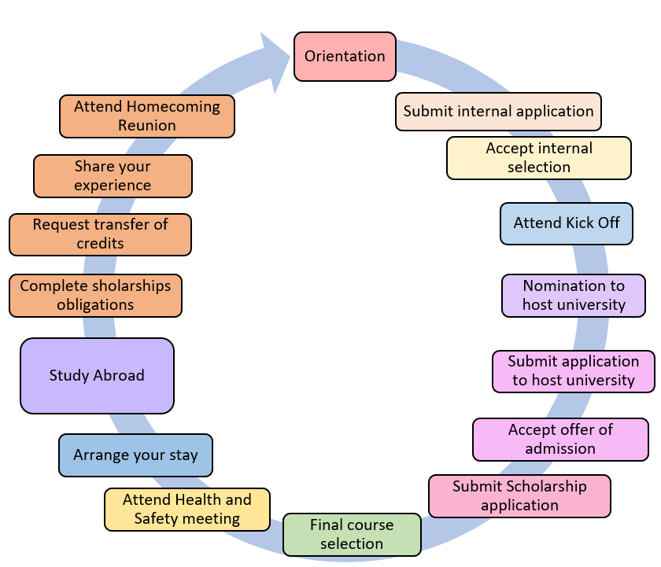
 |  | Check available scholarships through the website | Student
 |  | If applicable; make sure your passport is valid at least 6 months after your proposed return date. If it isn't, please request a new passport. | Student
Nomination | F: April – May  S: September | Nomination deadlines are April to May for Fall students. We will send confirmation of nomination.  For Spring students: September | Exchange coordinator
Application | March - May | Housing: Check housing requirements/availability the moment you are selected. | Student
 |  | Housing tip: Check HousingAnywhere | Student
 |  | Obtain documents such as transcripts, certificate of enrollment, etc. at student administration. | Student --> Front office, student administration
 |  | Anything to do with course approval or courses in general, please contact the exchange coordinator.  Important: check the credit conversion on the world map. Credits will be different than ECTS. | Student --> Exchange coordinator
 |  | Please check the tab for your study programme for all the steps to take. For course approval, you need to submit this form with your preferred (and back up) courses, including links to a detailed syllabus. Please note that it can take up to two weeks before you receive feedback. | Student
 |  | Finish your application before the host university deadline. | Student
 |  | When you have finished your application at the host university, the host university will let you know once you've been accepted. | Host-University
 |  | Q&A meeting in June for Fall students.  Q&A meeting in November for Spring students. | Student Exchange coordinator
Finances |  | Make sure to make a realistic budget based on the cost of living at your destination. | Student
 |  | Find available scholarships through the website and apply to them. | Student
 |  | Check the Cost of living overview | Student
 |  | Check the Budget template | Student
 |  | Scholarships – Check Wilweg.nl en Scholarship portal | Student
Erasmus+ Scholarship |  | Please check the Erasmus+ Scholarship website on how to apply and eligibility requirements. Note! You need to apply for your Erasmus+ Grant two months before your study abroad. | Student
Visa |  | If applicable; Follow the instructions of your host university about visa application and our own visa department. | Student
Health & Safety meeting | F: February – July  S: September - December | Register for and attend one Health & Safety meeting. It doesn’t have to be just before you leave, it can be any time in the year. You will receive an automatic invitation from uSis. See available dates here. | Student
 |  | Check if the country of your host university is safe to travel to here. | Student
Course approval | F: March – June  S: September - November | Please check the tab for your study programme for all the steps to take. For course approval, you need to submit this form with your preferred (and back up) courses including links to a detailed syllabus. Please note that it can take up to two weeks before you receive feedback. | Student
 |  | You need to register for at least 20 ECTS. The courses cannot have too much overlap with your taken Psychology courses, and it needs to be academically based. (i.e. Badminton will not receive ECTS). | Student
Online Learning Agreement |  | After approval for your courses, you need to fill out the Online Learning Agreement. This agreement needs to be signed by the exchange coordinator of Psychology, and the exchange coordinator of your host university. Note! This agreement is mandatory for your Erasmus+ Grant. You will receive more information during the Q&A session. | Student
Your travel |  | Although we recommend you to only book your transportation when your application is in order, if you make sure that your ticket is refundable or flexible, you can book your transportation in advance. | Student
Sustainable travel |  | Please check the various methods of sustainable travel here. We do recommend travelling in a sustainable method and you might receive a ‘Green Travel Top – Up’ with your Erasmus+ grant. | Student
Exchange |  | During Mobility; if you need to change courses, please fill in the form. After approval from your exchange coordinator, you need to fill out the ‘Changes during Mobility’ section of your Online Learning agreement. | Student --> Exchange coordinator
 |  | If you plan to travel after your exchange, make sure your passport is valid! | Student
 |  | Are you having some unexpected challenges? Do you not know what to do? Please contact us at exchangepsy@fsw.leidenuniv.nl . We are here to help! | Student --> Exchange coordinator
Return |  | Download your Transcript of Records or check with the exchange coordinator if it is submitted by the host institution. | Student --> Exchange coordinator
 |  | Submit your request for credit recognition in uSis and per email. | Student
 |  | Fill out the Study Report and your participation in the Exchange Pool. | Student
 |  | Check the requirements for the Erasmus+ Scholarship and make sure you fulfill your obligations. | Student
 |  | Attend the Homecoming Reunion meeting, | Student

