Manual online application system Master Honours Challenges

- Go to the following website: http://www.honoursacademyleiden.nl.
- Create an account through the “New user? Register here!” button or log in with your credentials if you have already registered before with this system. It is not possible to log in with your ULCN account – it is necessary to create a new account for this system. It is, however, possible to use your student e-mail (uMail) to create an account.
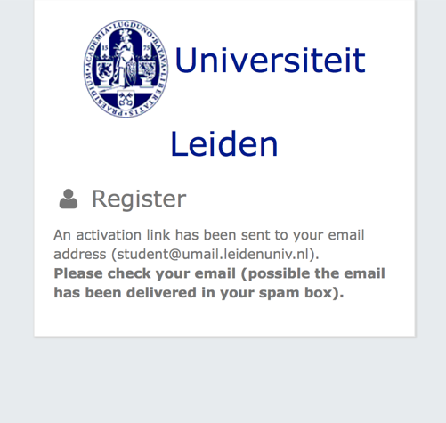
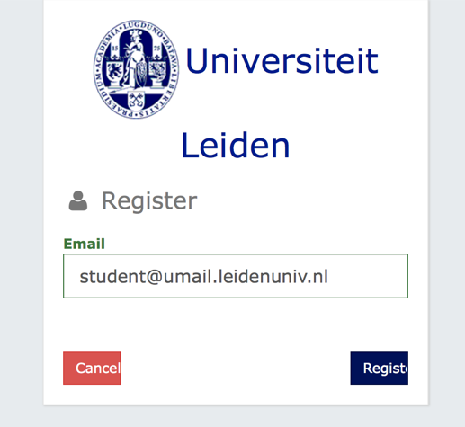
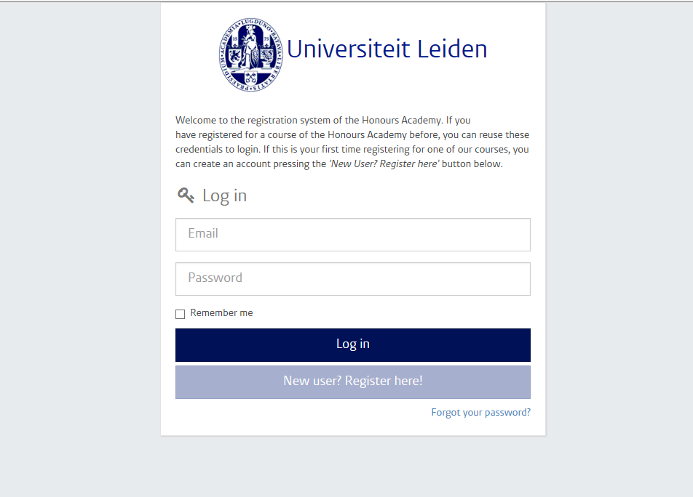
Step 1 & 2: Log in screen of the Honours Academy registration system
- Did you forget your password? Click on the “Forgot your password?” link right below. Fill in your e-mail address so that a new password can be sent to you.
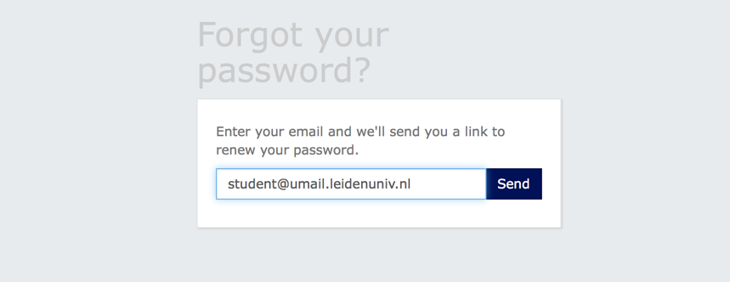

- Once you are logged in, you will get an overview of the options for activities for which you can register. Select here the option of Master Honours Challenges for the period in which you want to enroll.

Step 4: Select “Master Honours Challenges”

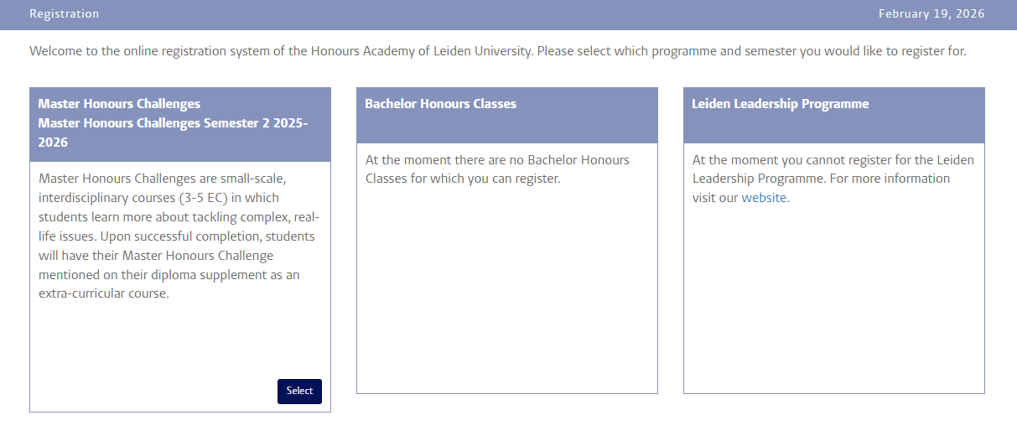

- In front of you, you will find a questionnaire. Please fill it in with your personal information before selecting the Master Honours Challenges of your choice. On the right side of the “Profile” section, there is a plus icon which if you click on it, gives you a frame where you can fill in or update your profile information. Note that the question 8 of the “More information” box requires you to fill in your average grade in a 10-point scale. Make sure to put your transcript from your Bachelors in question 9.
Click on the “save” button if you are finished and continue your registration.

Step 5: Fill in your profile and personal information
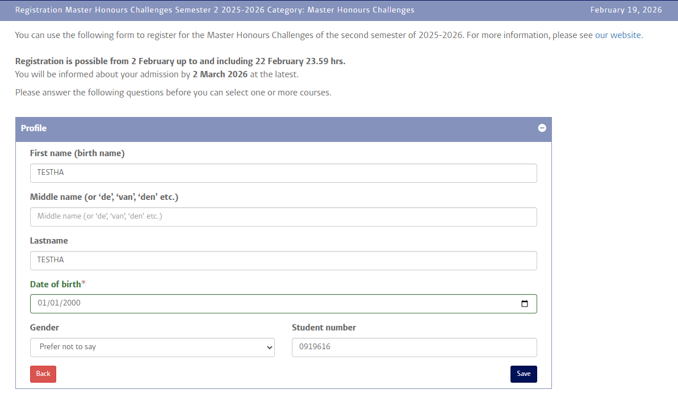
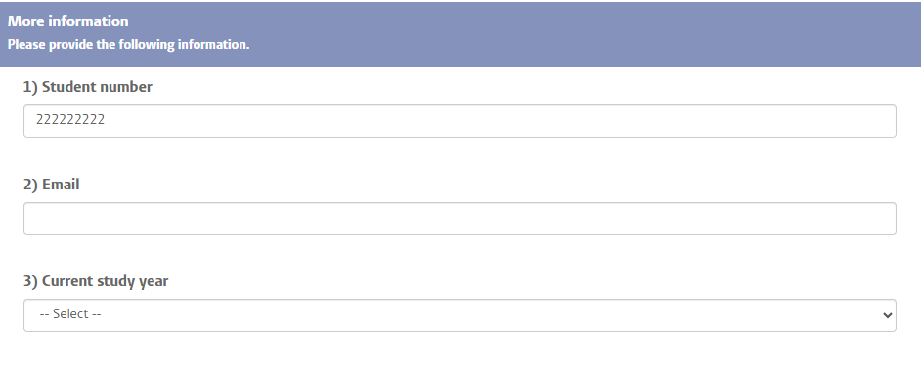

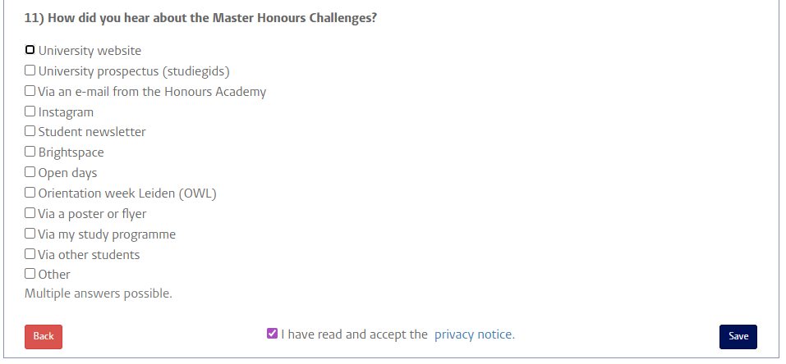
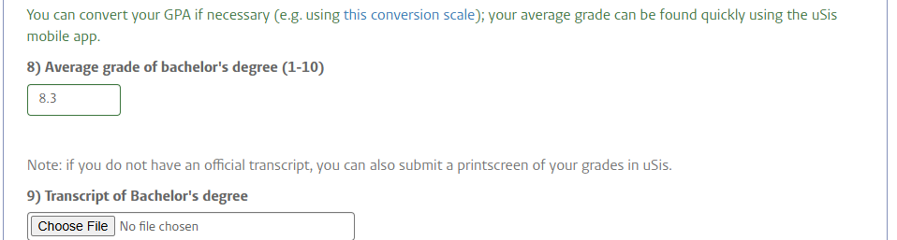

- Once you have successfully filled in the questionnaire, you will arrive at the page where you can select the Master Honours Challenges of your choice. You can put in your selections by clicking on the arrow icon next to the class name.
Please note that you can always return to the questionnaire to modify your answers (“Back to questionnaire”).

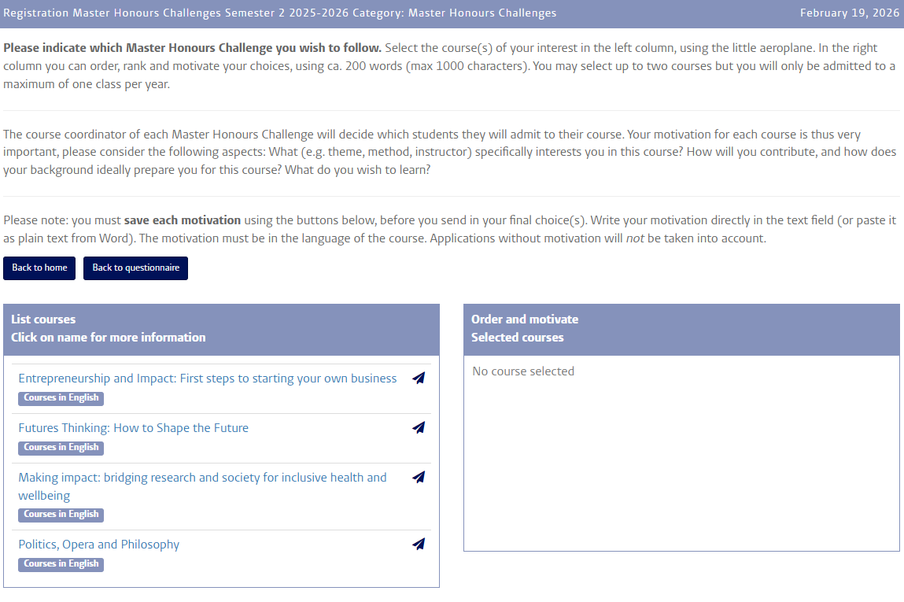

Step 6: Give your preferences and motivation for Master Honours Challenges

- Due to the fact that only a small number of students can be enrolled in a Masters Honours Challenge, we kindly request you to sign up for multiple courses. You can select up to 4 courses. Select a course from the column on the left side by clicking on the airplane icon. Then the selected course will appear in the column on the right side, along with the other courses of your preference. For each selected course you must write a course-specific motivation. Please type your motivation directly in the form instead of copy/pasting it from Word. Don’t forget to save it. Should you want to remove a course from the list of your course preferences, click then on the bin icon. Use the blue arrows to change the order of your course preferences.

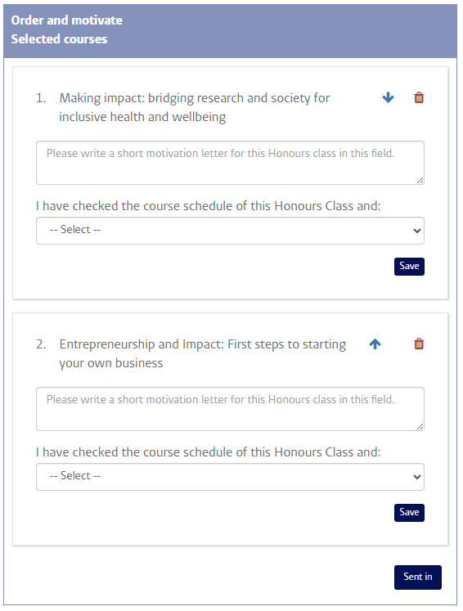

- If you have selected all the courses of your preference and added your motivation for all of them, you can then click on the “Send in” button. Then you will receive an automated confirmation e-mail, and your application will be submitted to the Honours Academy. If you haven’t received this e-mail in your inbox, please check your spam folder. Please note that before the application deadline it remains possible to log in and modify your application, including your course preference and motivation. After the deadline, course lecturers will make the selection of students for their Master Honours Challenges. You will then receive an e-mail notifying you whether you have been selected for a Master Honours Challenge and if so, which one.

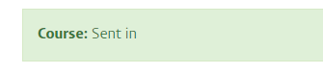

Should you have any questions that haven’t been addressed in this manual, or should you have any suggestions to improve the online application system for the Master Honours Challenges, please send an e-mail to maclasses@ha.leidenuniv.nl.

