Manual online registration system Honours College courses

- Go to the following website: http://www.honoursacademyleiden.nl.
- Create an account through the “New user? Register here!” button or log in with your credentials if you have already registered before with this system. It is not possible to log in with your ULCN account – it is necessary to create a new account for this system. It is, however, possible to use your student e-mail (uMail) to create an account.

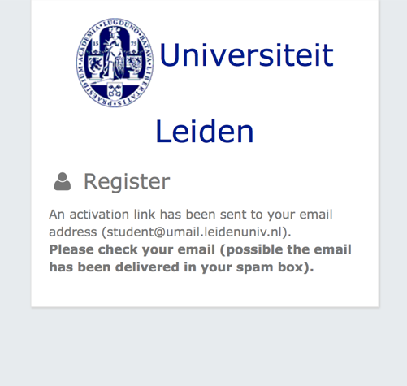
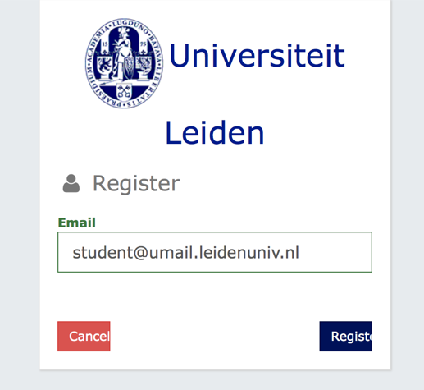

- Log in the Honours Academy registration system
- Did you forget your password? Click on the “Forgot your password?” link right below. Fill in your e-mail address so that a new password can be sent to you.

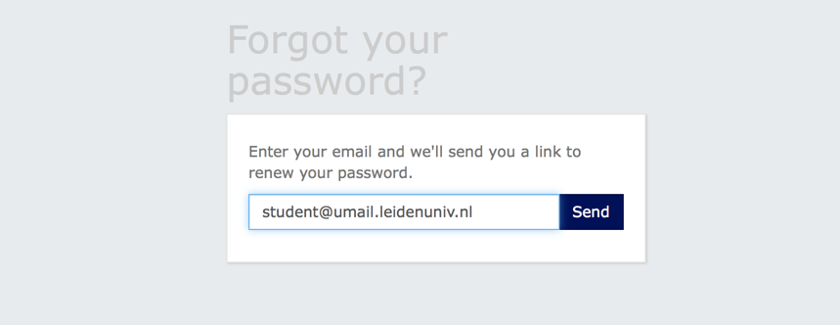

- Once you are logged in, you will get an overview of the options for activities for which you can register. Select here the option of Honours College courses for the period in which you want to enroll.

- Select “Honours College courses”

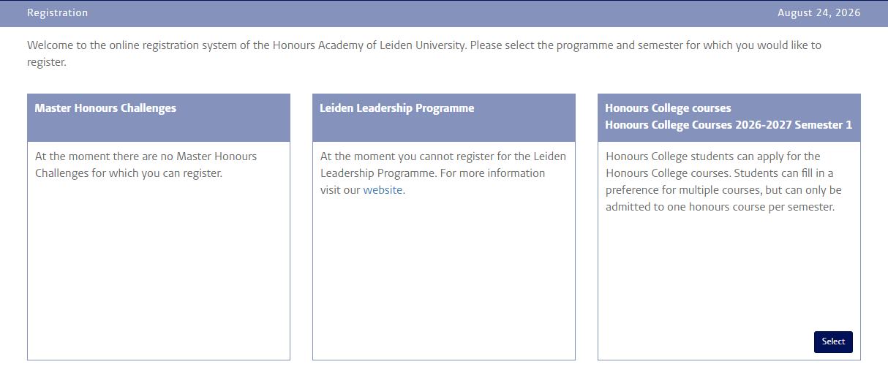

- In front of you, you will find a questionnaire. Please fill it in with your personal information before selecting the Honours College courses of your choice. On the right side of the “Profile” section, there is a plus icon which if you click on it, gives you a frame where you can fill in or update your profile information. Click on the “save” button if you are finished and continue your registration.

- Fill in your profile and personal information
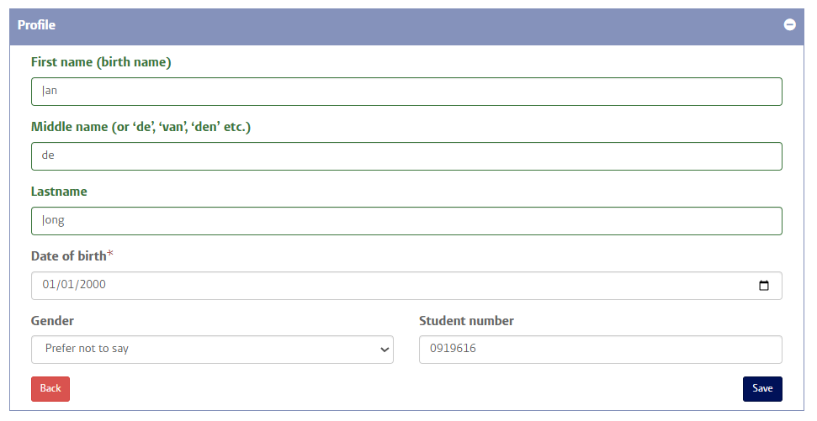
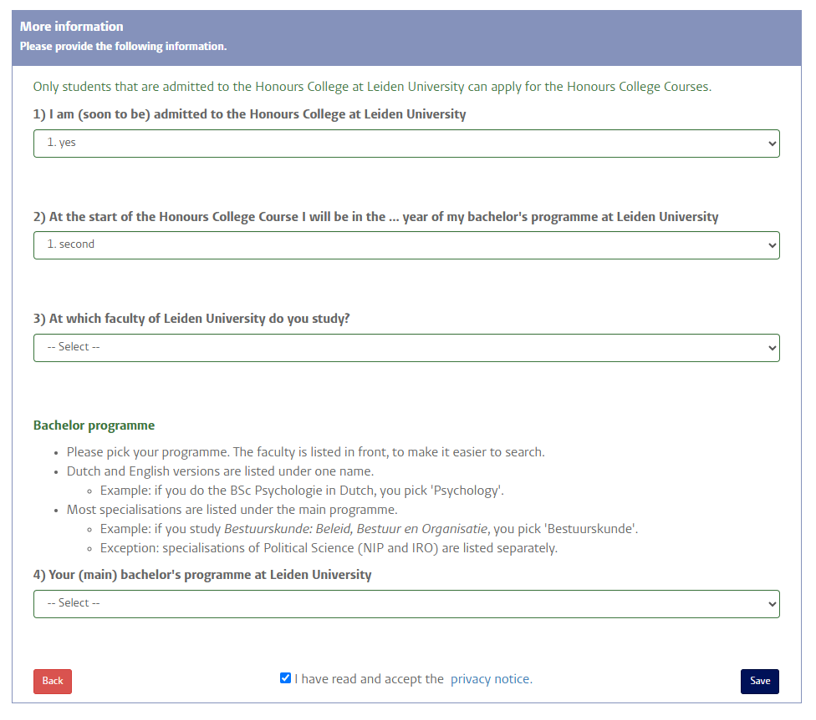
- Once you have successfully filled in the questionnaire, you will arrive at the page where you can select the Honours College courses of your choice. Please note that, you can always return to the questionnaire to modify your answers (“Back to questionnaire”).

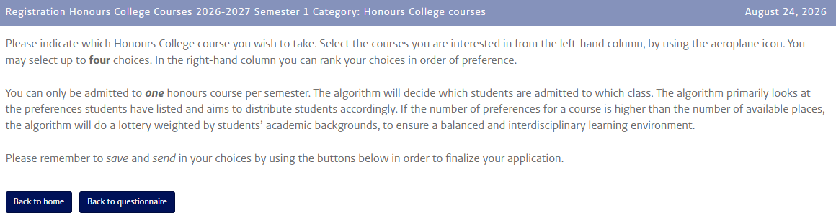


- There are limited places available in Honours College courses, therefore we kindly request you to sign up for 3, max 4 courses. Select a course from the column on the left side by clicking on the airplane icon. Then the selected course will appear in the column on the right side, along with the other courses of your preference. Should you want to remove a course from the list of your course preferences, click then on the bin icon. Use the blue arrows to change the order of your course preferences. Please note that before the registration deadline it remains possible to log in and modify your course choices.
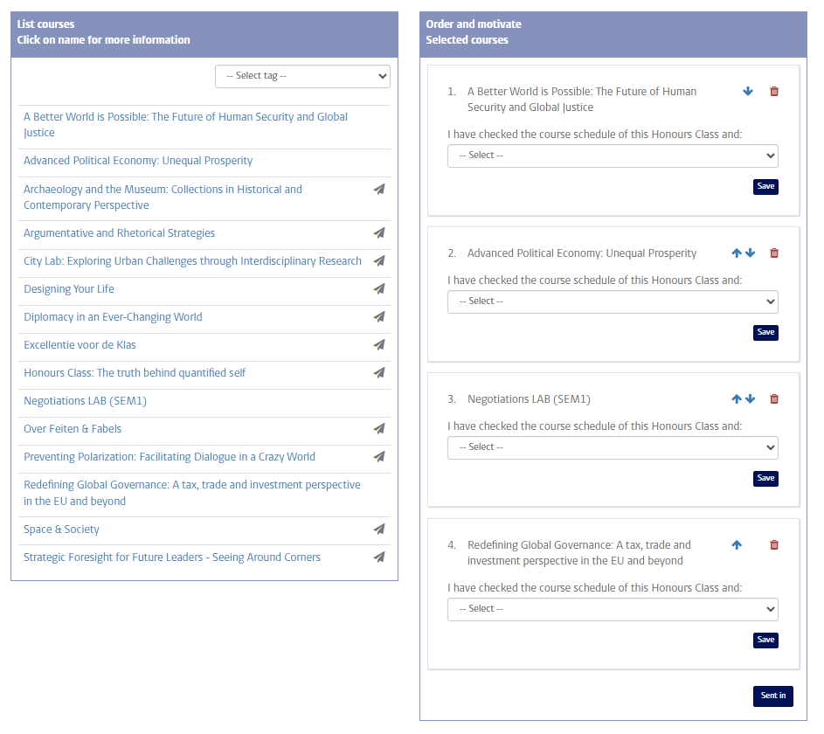
- Give your 4 preferences for Honours College courses

- If you have selected all the courses of your you can then click on the “Send in” button. Then you will receive an automated confirmation e-mail, and your registration will be submitted to the Honours Academy. If you haven’t received this e-mail in your inbox, please check your spam folder. Please note that before the registration deadline it remains possible to log in and modify your registration.

- Send in your preferences
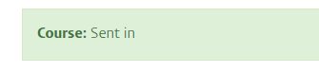

- After the closing of selections, you will receive an email stating which course you have been placed. Please be assured that the Honours Academy will place you and enroll you in uSis in one of the four courses of your choice.

Should you have any questions that haven’t been addressed in this manual, or should you have any suggestions to improve the online registration system for the Honours College courses, please send an e-mail to hc-courses@ha.leidenuniv.nl.

